Accela Mobile Eclipse Plug-in
Version 3.0
Maintenance Guide

Revision History
Author | Date | Version | Description
Gordon Chen | 2012-09-05 | 1.0 | Initial Version
Gordon Chen | 2013-02-25 | 3.0 | Updated for V3.0

This document provides instructions to maintain the Accela Mobile Project Plug-in developed for Eclipse, build a deliverable package, then deploy it onto a website for online install / upgrading.
This document consists of the following chapters:
- Prepare PDE In Eclipse.
- Plug-in Project Overview.
- Maintain Plug-in Project.
- Build Deliverable Plug-in Stuffs.
- Deploy And Install Plug-in.

  - Prepare PDE in Eclipse
Before working on the plug-in project, we should make sure PDE (Plug-in Development Environment) is available in Eclipse. Usually PDE is included in Eclipse unless your Eclipse is a very old version or a customized version which doesn’t include it.
To check that, please open your Eclipse, select menu: File -> New -> Project, then the New Project dialog will pop up. If the Plug-in Development item is available in the wizard list, which means the PDE is ready for use. Refer to the following screen shot:
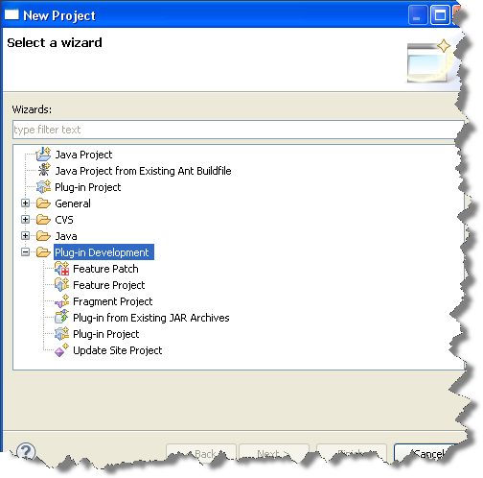

  - Plug-in Project Overview
The Accela Mobile Project Wizard plug-in provides three different wizards for users to create three different template projects (Agency App, Citizen App, A311 App) accordingly.
  - Plug-In UI Flow
If you are asked to update a wizard’s UI such as adding new pages, adding new input fields in an existing page, you have to follow the steps below:
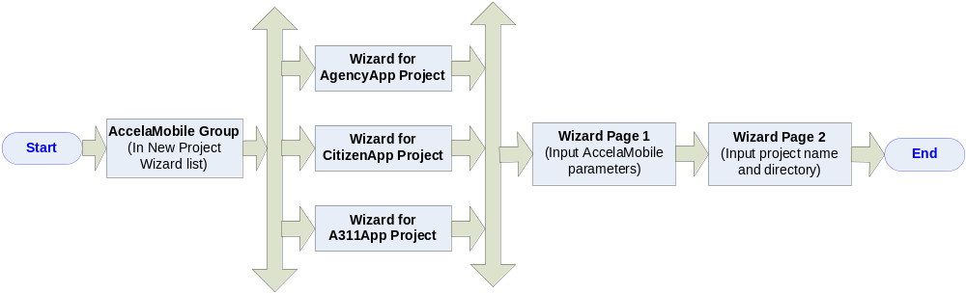
  - Source Structure
This plug-in project contains several Java source files which present wizards pages and process data collected from these pages. Refer to the following screen shot:
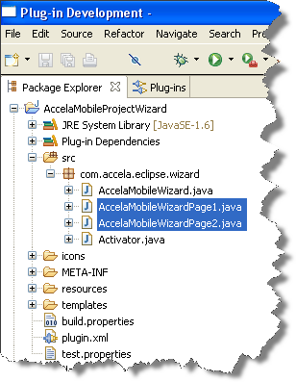
Activator.java:
It is the entry point of the plug-in, usually we needn’t update its code.
AccelaMobileWizard.java:
It defines the wizard’s page flow, and actions when the wizard is started and finished.
AccelaMobileWizardPage1.java:
It defines the UI and the corresponding logic of the 1st page in the wizard’s flow.
AccelaMobileWizardPage2.java:
It defines the UI and the corresponding logic of the 2nd page in the wizard’s UI flow.

  - Maintain Plug-in Project
  - Add new page in an existing wizard
If you would like to add new pages in the wizard flow, or add some new UI elements in an existing page, please refer to the following steps:
    - Create a new page.
Create a new Java file, make sure it inherits from WizardPage class or its sub classes.
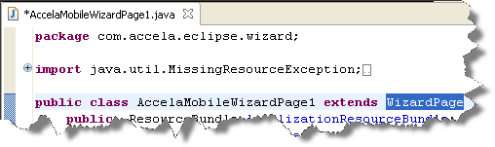
    - Add UI elements in the page.
If you would like to customize the page’s UI, you must create the UI elements in the class’s createControl method (refer to AccelaMobileWizardPage1.java).
(Note: If you would like to modify the UI layout of an existing page, you can do the same here)
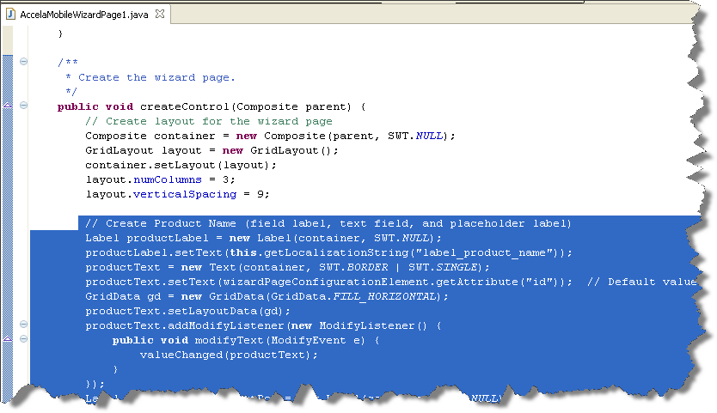
If you would like to reuse the page’s UI which is already defined in the super class,, you can ignore the createControl method, and just implement its constructor method (refer to AccelaMobileWizardPage2.java).
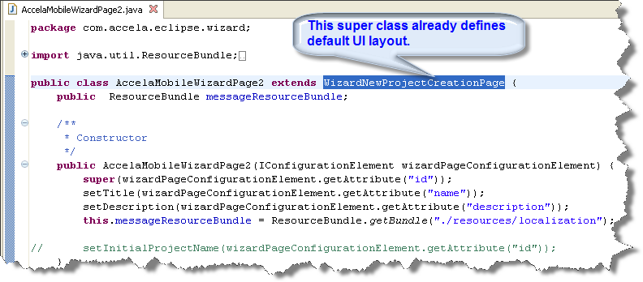

    - Add the new page into wizard flow.
The last step is to add the new page into the wizard’s UI flow.
Please open the Java file AccelaMobileWizard.java, scroll down to the addPages method, initialize the page object, then add it into UI flow, lastly write code to process its data in performFinish method. Refer to the following screen shot: 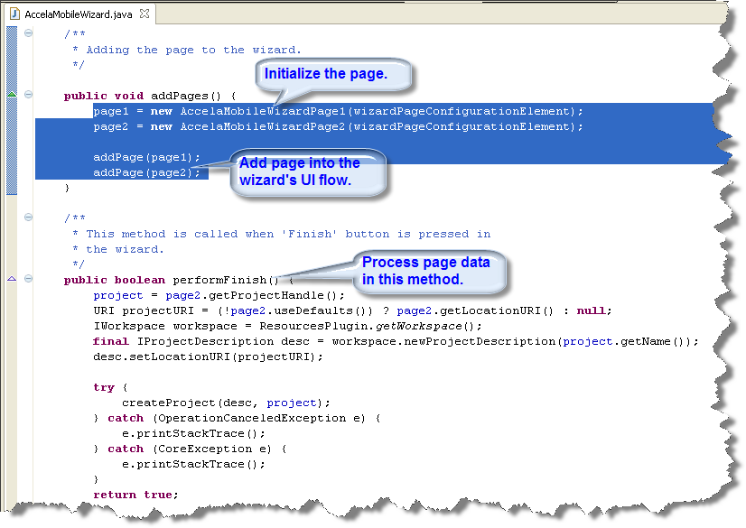

  - Add new wizard in the plug-in project
For the time being, Accela Mobile Project Wizard plug-in provides three different wizards for three different template projects (Agency App, Citizen App, A311 App).
If you would like to add a new wizard for a 4th template project, please refer to the following steps:
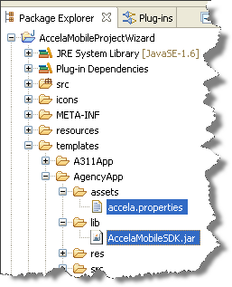
    - Prepare template project folder
First you need to create a complete Android
template project which can be run, and copy
its project folder to this plug-in project’s templates
directory in which the other template projects reside,
then copy the lib folder and assets folder from
AgencyApp template project to this new template.
For the file directory, refer to the screen shot
on the right side.

    - Configure the new wizard in XML
Open the plugin.xml file under the AccelaMobileProjectWizard project, add a <wizard> node for the new wizard (refer to the following screen shot):
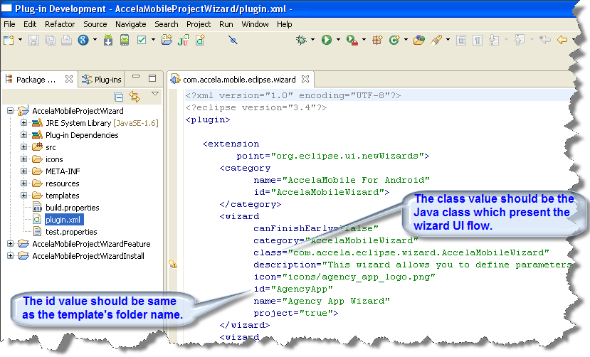
Here is the meaning of these attributes under the <wizard> node:
canFinishEarly: Indicates whether the Finish button is activated or not before the wizard reaches to the last page.
category: Defines the name of the wizard group which is shown in Eclipse’s New Project dialog.
class: Defines the Java class which presents the current wizard and handles data.
description: Defines the text string which is shown in the wizard page.
icon: Defines the wizard’s icon, which will be shown in front of the wizard name in Eclipse’s New Project dialog.
id: Defines the wizard’s id. Note that its value must be same as the wizard’s template folder name because our Java code refers to it in logic handling.
name: Defines the wizard’s name, which will be shown in Eclipse’s New Project dialog.
project: Indicates whether it is shown in Eclipse’s New Project dialog or not.

    - Implement the new wizard in Java code
For now, the three wizards defined in the plug-in project reuse the same wizard class (AccelaMobileWizard.java), so you can skip this section if the new wizard will also reuse the same wizard.
If the new wizard requires some different UI layouts or data handling logic, please refer to section 3.1 Add new page in an existing wizard for how to add page, customize page UI, and process page data.

  - Build Deliverable Plug-in Stuffs
  - Update The Plug-in Project
In the AccelaMobileProjectWizard project, make sure all changes including code changes and template changes are all completed, then open the plugin.xml file to update the Version number.
Note the version number is very important, especially when you are building a new release for users to upgrade the installed plug-in (refer to the following screen shot):
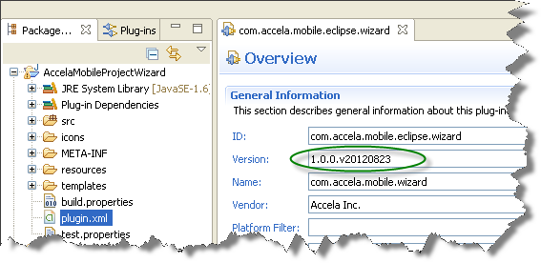
  - Update the Feature Project
In the AccelaMobileProjectWizardFeature project, open the feature.xml file under the feature project, then update the Version number in the Overview tab (refer to the following screen shot):

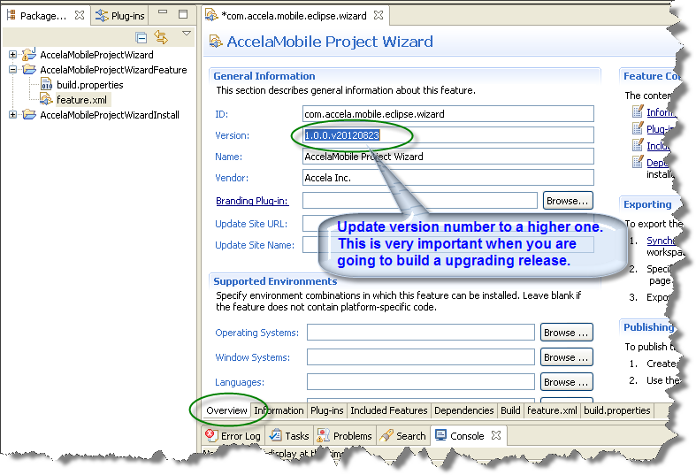

Switch to “Plug-ins” tab from the bottom tab bar, click the Versions button, then tick the last option in the pop-up dialog, and click Finish button.
You will see the plug-in displayed in the list box will be refreshed (refer to the following screen shot):
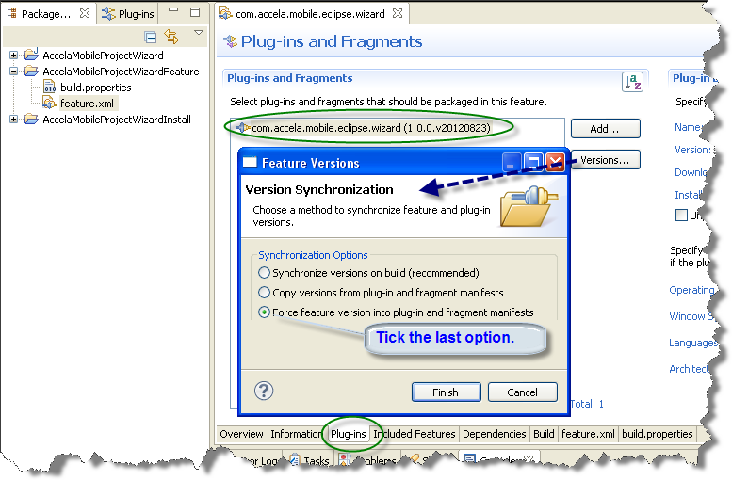
Important Note: After you modify the project wizard(the 1st project node in the above screen shot) , please remember to open this dialog, tick the last option and click Finish button. Otherwise the changes will not be synchronized to this feature.
  - Build Update Site Project
In the AccelaMobileProjectWizardInstall project, double click the site.xml file.
In the Site Map tab, right click on the current feature item listed under the Accela Inc. group, then select Remove menu to delete it (refer to the following screen shot):
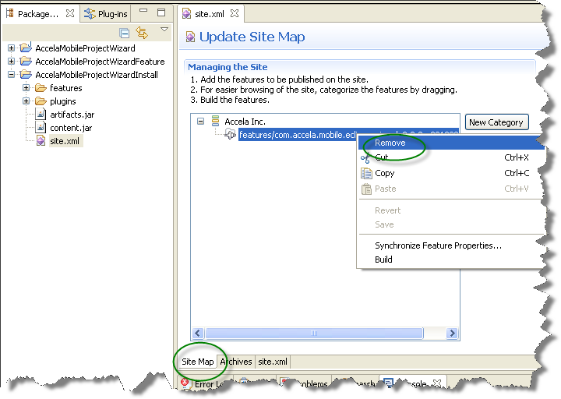

Select the the Accela Inc. group again, click Add Feature button, then select the new feature from the pop-up dialog and click OK button (refer to the following screen shot):
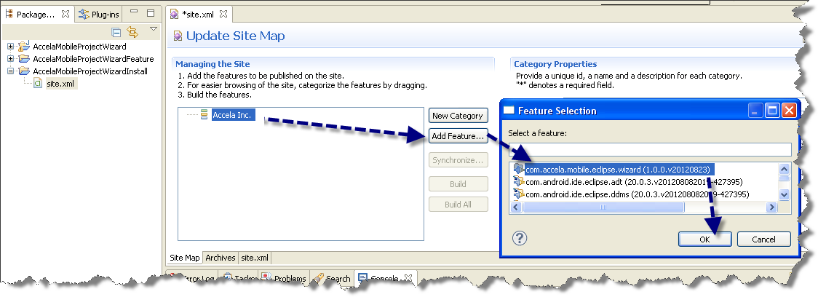

Click the Build All button, the update site project will be built to generate the files to be published.
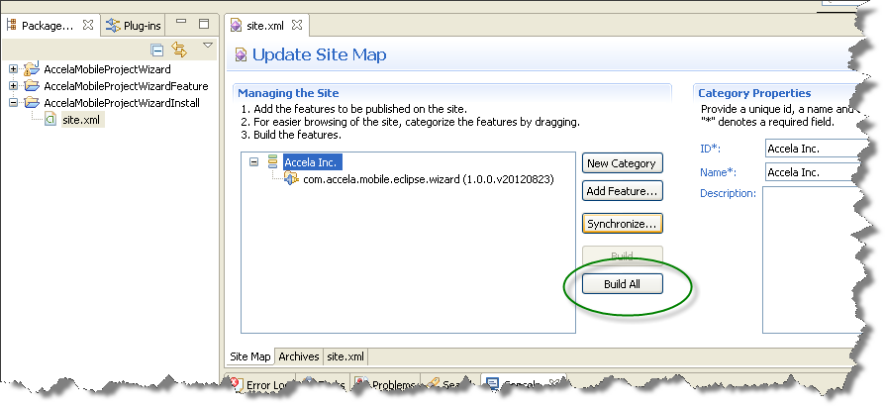

  - Deploy And Install Plug-in
  - Deploy the plug-in to website
First make sure you have a web server which URL can be accessed by the target users, then copy the built update site files to a public directory on the web server (refer to the following screen shot):
Note: If the web server has cached data, please restart it to make the changes take effect.
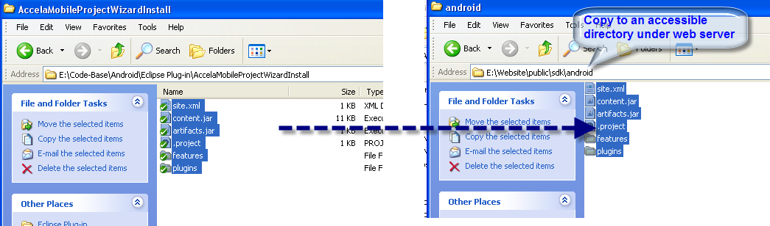
  - Install the plug-in in Eclipse
Based on different situations, you have three ways to install the Accela Mobile plug-in in Eclipse from web URL or local directory, or just copy the plug-in Jar package into Eclipse’s plugins folder directly.
    - Install the plug-in through Eclipse
Select Eclipse’s menu: File -> Help -> Install New Software, then the Add Repository dialog will pop up.
In the Location field, input the URL which provides the plug-in stuffs, or click the Local button (or Archive) to select the plug-in in local disk (refer to the following screen shot):
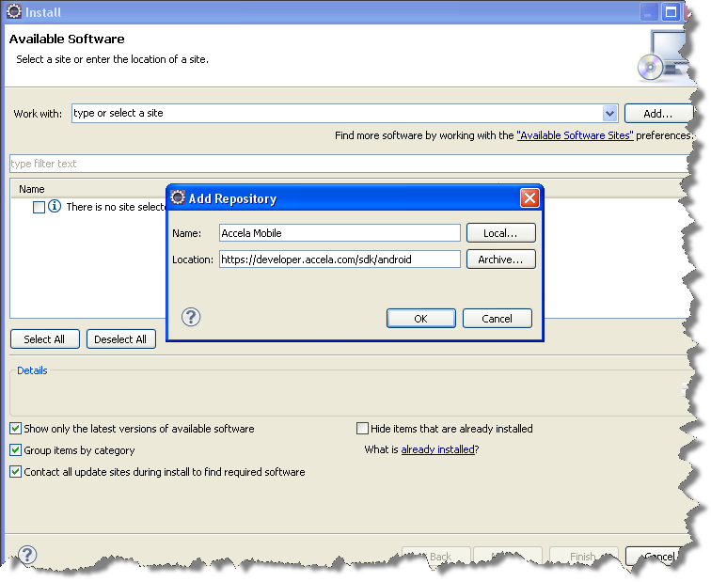
Note: If you have downloaded the Accela Mobile SDK offline install package from https://developer.accela.com/sdk/android.zip, and unzipped it to a folder on local disk,
You can click the Local… button in the above dialog and select the folder for offline install.

In the plug-in in the list box, select it then click Next to complete the installation (refer to the following screen shot):
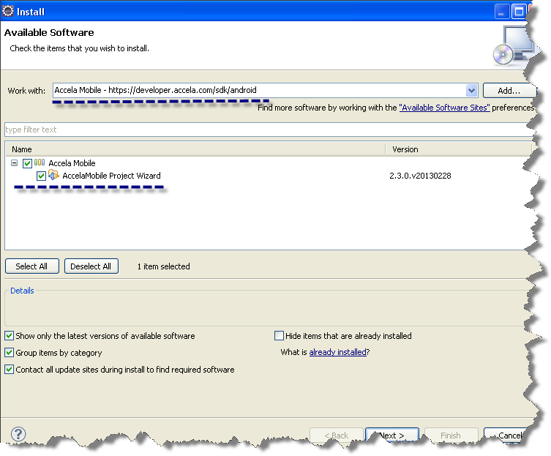
Note: If the connection fails with “Bad Gateway” error in the above Install dialog, please disable proxy setting in IE browser with navigation path Tools -> Internet Options -> Connections -> LAN Settings.

    - Install the plug-in by manual copy
First you should have got the plug-in Jar file, typically its name looks like com.accela.mobile.eclipse.wizard_1.0.0.v20120906.jar, in which the last eight digits are combinations of year, month, and date.
The next step is to copy this Jar to Eclipse’s plugins folder (refer to the following screen shot), then you can open Eclipse to use the Accela Mobile project wizard.
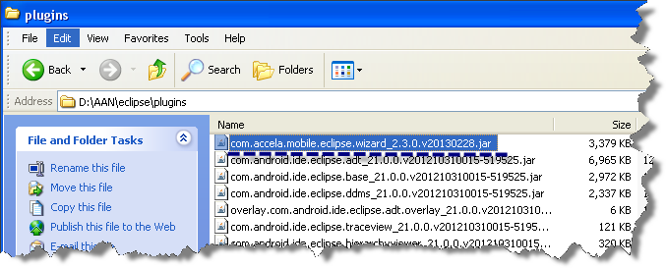
  - Use the plug-in to create template projects
After the plug-in is installed, you may use it to create Accela Mobile template projects with the following steps:
Select menu: File -> New -> Project, then the New Project dialog will pop up.
You will see the Accela Mobile project wizard in the list, select a project type then click Next (refer to the following screen shot):
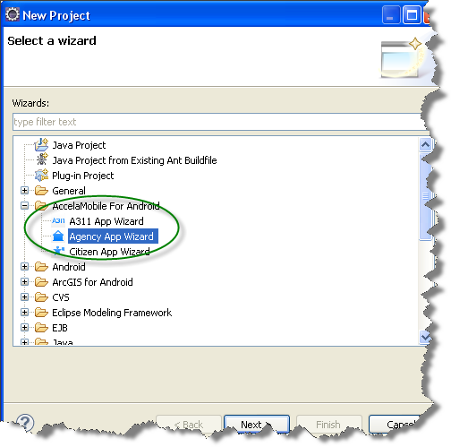
In the first page, input all parameter values, then click Next (refer to the following screen shot).
Important Note: The Android SDK Version means the Android API Level on which the application will be run, so please make sure the corresponding Android SDK version has been installed before selecting a level. Otherwise error will occur when you build or run the project.
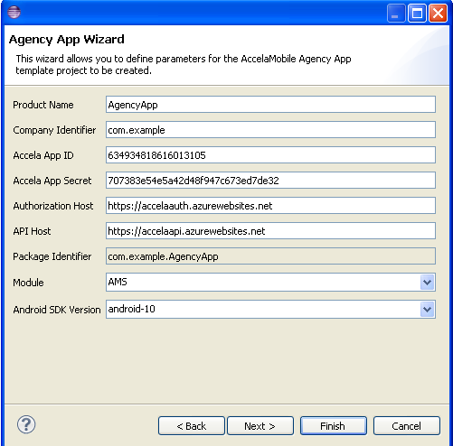

In the second page, input project name, then click Finish (refer to the following screen shot):
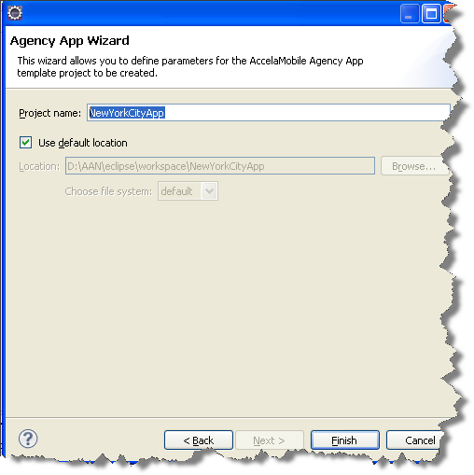

Then a new project will be created and listed in the project tree panel on left side, you can run it directly because it is a complete Android project which can be run directly (refer to the following screen shot):
